3.9. Current contour in a homogeneous magnetic field

The permanent magnet 2 is fixed on the stand 1 so that its lines of force lie in a horizontal plane (Fig. 17). Between the poles of the magnet, a frame 3 is suspended in a thread 4, to which a weight 5 is tied at the bottom and an arrow 6 is attached in the middle, indicating a direction perpendicular to the plane of the frame. The frame winding is connected to the power source 8 through a three-pole switch 7.

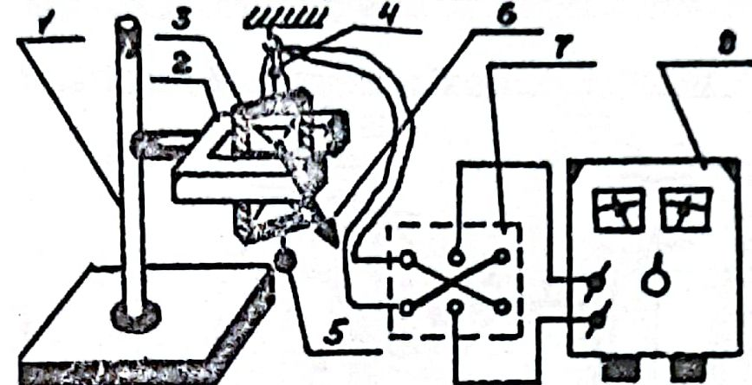

Fig. 17 Scheme of the experiment: 1 - stand, 2 - permanent magnet, 3 - frame, 4 - thread, 5 - weight, 6 - arrow, 7 - three-pole switch, 8 - power source.

At first, the frame is oriented so that its arrow points in an arbitrary direction towards the poles of the magnet, except for the angles π/2 and 3π/2. Close the switch 7. The frame turns so that its arrow points to one of the poles of the magnet. Switch the switch to the other position, the frame rotates through an angle π, and its arrow points to the other pole of the magnet.

Passing the gap I through the frame produces a magnetic moment , where N is the number of turns. In the magnetic field of the permanent magnet, the frame B rotates so that because in this state the system has minimum energy (Experiment 3.5).

When the switch is switched, the direction of the current in the frame changes to the opposite, which means that the magnetic moment of the frame turns by an angle π and becomes antiparallel to the induction vector of the permanent magnet. At this orientation of the vectors and the energy of the system is maximum and it occupies a labile state. Therefore, the frame goes to a stable state. It rotates so that the vectors and point in the same direction.